**IST 659 LAB Assignment NO -7**

1. Add an employee using your own name and create a project assignment for yourself using existing project id.

**Query:**

/*1) Add an employee using your own name */

INSERT INTO employee VALUES (11118, 'Rahuk', 'Rathod', 100000);

/* updating the employeeFName from Rahuk to Rahul */

update employee

set employeeFName= 'Rahul'

where employeeID=11118

/*create a project assignment for yourself using existing project id.*/

INSERT INTO projectAssignment VALUES (11118, 1003, 'manager');

**Result:**

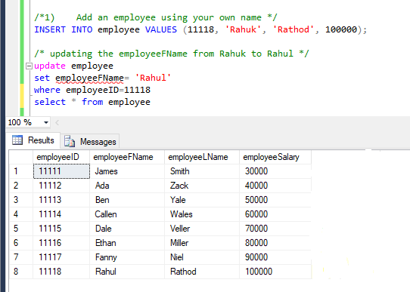

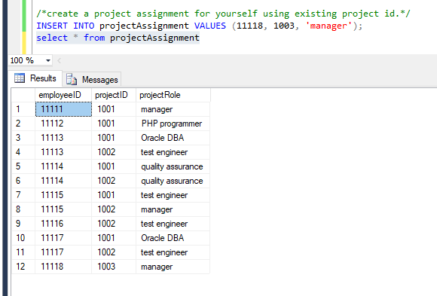

1. Write a scalar function that returns the average salary of the Employees

**Query:**

/* scalar function that returns the average salary of the Employees*/

create function averageSalary(@i int)

returns decimal(10,1)

as

begin

declare @ret INT;

select @ret= avg(employeeSalary)

from employee

return @ret;

end;

/* call the function averageSalary*/

select dbo.averageSalary(8) as averageSalary

**Result:**

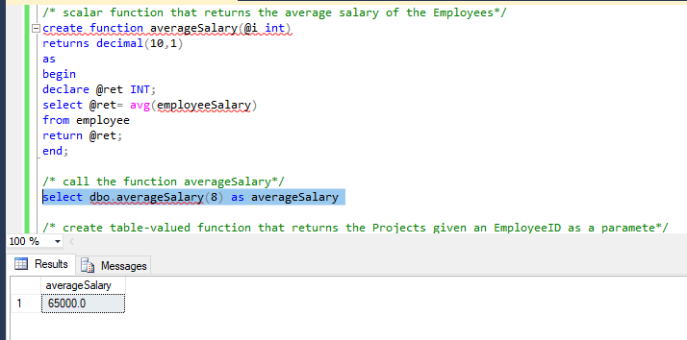

1. Write a table-valued function that returns the Projects given an EmployeeID as a parameter and
   1. Show the function created
   2. return the results for your own project

**Query:**

/* create table-valued function that returns the Projects given an EmployeeID as a paramete*/

create function employeeProject(@employeeID int)

returns table

as

return

(

select pa.projectId as employeeProject

from projectAssignment pa

Inner Join employee e on pa.employeeID = e.employeeID

Inner Join project p on pa.projectID = p.projectID

where e.employeeID = @employeeID

)

drop function dbo.employeeProject

/* call the function employeeProject*/

select * from employeeProject(11118);

**Result:**

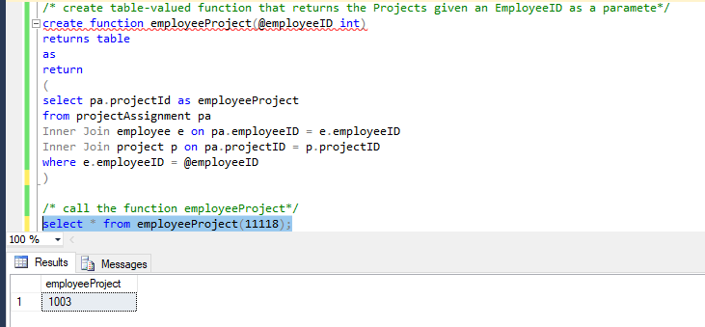

1. Alter the Employee table to add a new column called ‘Num of Projects’ which can be **INTEGER** data type. Write a procedure that updates employee table with the total projects assigned to each employee (to the newly created column)

**Query:**

/*Alter the Employee table to add a new column called ‘Num of Projects’ */

alter table employee add NumOfProjects int;

select * from employee

CREATE PROCEDURE TOTAL_PROJ

AS

BEGIN

UPDATE EMPLOYEE

SET NumOfProjects = projCount.total_count

FROM

(

SELECT employeeID,count(projectID) AS total_count

FROM projectAssignment

GROUP BY employeeID

) projCount

WHERE employee.employeeID=projCount.employeeID

END;

EXEC TOTAL_PROJ;

**Result:**

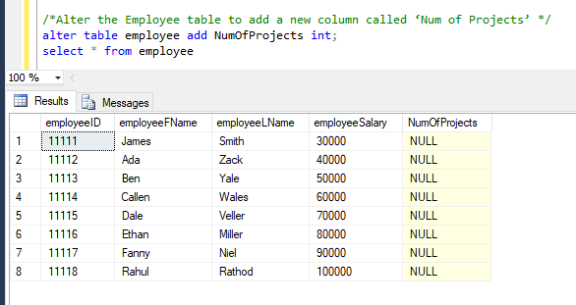

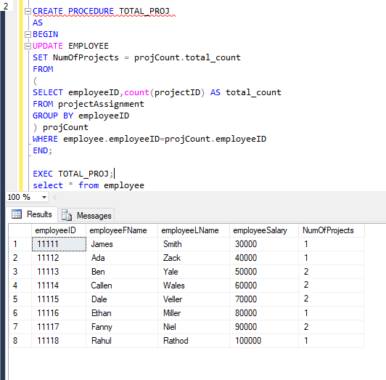

1. Create a trigger that can update the num of projects whenever a new project is assigned to an employee.

Test the trigger with the below insert

* 1. INSERT INTO projectAssignment VALUES (11114, 1003, ‘quality assurance');
  2. INSERT INTO projectAssignment VALUES (11115, 1003,'test engineer');

**Query:**

CREATE TRIGGER NumofProjectsTrigger

ON projectAssignment

FOR INSERT,UPDATE

AS

IF @@ROWCOUNT >= 1

BEGIN

UPDATE EMPLOYEE

SET NumOfProjects = projCount.total_count

FROM

(

SELECT employeeID,count(projectID) AS total_count

FROM projectAssignment

GROUP BY employeeID

) projCount

WHERE employee.employeeID=projCount.employeeID

END;

INSERT INTO projectAssignment VALUES (11114, 1003, 'quality assurance');

INSERT INTO projectAssignment VALUES (11115, 1003,'test engineer');

**Result:**

